**Hive:**

We can make use of hive replication V2,

Commands like:- “REPL DUMP - REPL LOAD - REPL STATUS”

Hive event-based replication is configured between the primary and secondary clusters. This replication consists of two distinct phases: bootstrapping and incremental runs.

[Hive ReplicationV2](https://cwiki.apache.org/confluence/display/Hive/HiveReplicationv2Development) (also called Replv2) has the following advantages over the first version of Hive replication that used Hive [IMPORT-EXPORT](https://cwiki.apache.org/confluence/display/Hive/LanguageManual+ImportExport):

Considerations for Replv2:-

As of Hive 3.0.0 release : only managed table replication where Hive user owns the table contents is supported. External tables, ACID tables, statistics and constraint replication are not supported.

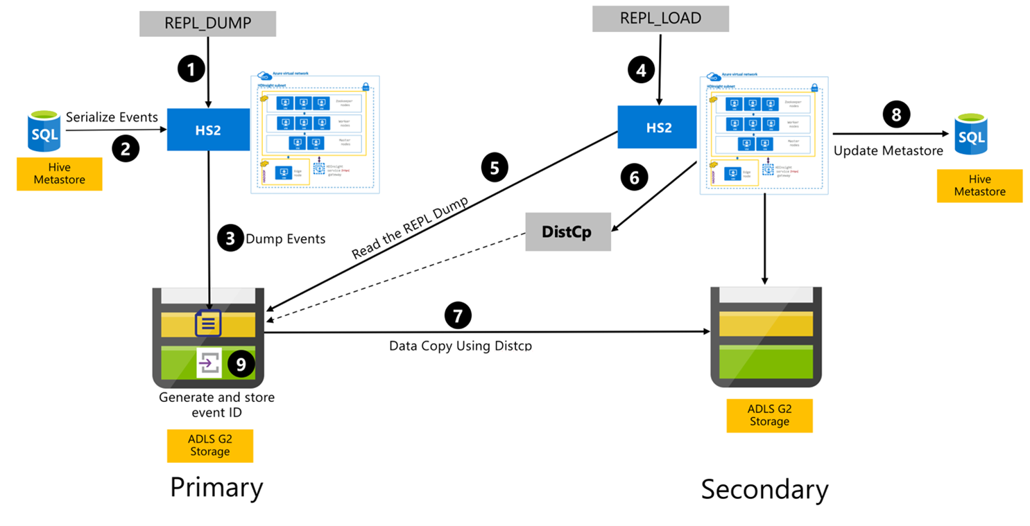

HBase:

Using snapshot:

Take a snashot

List a snapshot

Export snapshot.

Clone or restore snapshot.

HDFS:

Distcp tool

Some automation tools:

DistCP with Oozie.

DataTorrent HDFS to HDFS Line Copy App